Video Activity 1
- potatoes

Video Activity 2
Cheese, pasta, | sandwich.
Salad, vegetables, | soup.
Bowl, bottle, | plate.
Cup and | glass.

Video Activity 3
1. | Mr Friendly went to Jim and Jenny's classroom.
2. | They made a pasta salad.
3. | They got vegetables for us!
4. | My favourite kind of soup is sock soup!

Video Activity 4
1. | Wash the glasses.  Carry the plates.  Don’t drop the bowl!  We mustn’t be late.
2. | I’m boiling the pasta.  I’m frying the fish.  I’m starting the dinner.  Can you try this?
3. | Mum, stop crying.  Mum, don’t cry.  I’m cutting the onions.  It’s all right.

Video Activity 5
- We make paper from trees .
- We eat the leaves of the lettuce plant.

Vocabulary 1
- F
- T
- T
- T
- T
- F
- T
- F
- T

Vocabulary 2
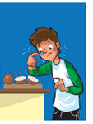 | cry | 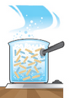 | boil
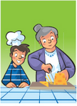 | cut | 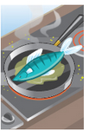 | fry
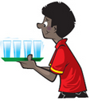 | carry | 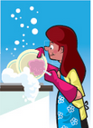 | wash
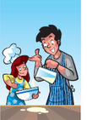 | cook | 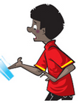 | drop

Grammar 1
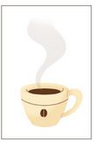 | I had coffee yesterday. I didn't have lemonade.
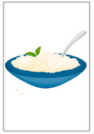 | I had rice yesterday. I didn't have chicken.
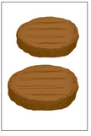 | I ate hamburgers for lunch. I didn't eat a sandwich.
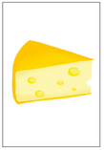 | I ate cheese for dinner. I didn't eat salad.
Grammar 2
1 Yesterday, I helped my mum.
2 I cooked dinner with her.
3 I fried some eggs.
4 I boiled some potatoes.
5 I washed the carrots, too.
Skills

- Last week, I went for a picnic.
- Last week I wanted to make a sandwich .
- My dad is a cook and last Monday he made a big chocolate cake.

