Video Activity 1
- a rainbow
- snow
- a lake
- umbrellas
- a kite

Video Activity 2
1 Hot, cold, sun, sunny.
2 Wind, windy , cloud, cloudy.
3 Snow, it's snowing, rain , it's raining.
4 I can see a rainbow .

Video Activity 3
Look at | those grey clouds.
Where's Farmer | Friendly today?
He was | in the mountains.
We were in the snow, | but we weren't cold.

Video Activity 4
It's hot and sunny | It's cold and windy | It's snowing
t-shirt  shorts | sweater  scarf | coat  boots

Video Activity 5
- thermometer
- weather vane

Vocabulary 1
- sunny
- rain
- wind
- cloud
- cold
- snow
- hot
- rainbow

Vocabulary 2
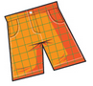 |  | 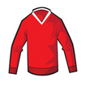
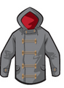 |  | 
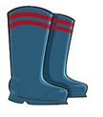 |  | 

Grammar 1
1 Yesterday was great.
2 Mum and Dad weren’t at home, but I was!
3 There was a great film on TV.
4 The film was about a party.
5 At the party, there were lots of clowns.
6 The film was very funny!
Grammar 2
- Yes, there was.
- No, there weren't.
- No, there weren't.
- Yes, there was.
Skills
- My family
- The weather
- My favourite place

