**Video Activity 1**

Watch the video. What don't you see?

|  |  |
| --- | --- |
| * a phone * a garden * a lift * a kite * stairs |  |

**Video Activity 2**

Watch the video. Say the chant, then match the sentence halves.

|  |  |
| --- | --- |
| grandparents, grown-ups. son. cousin. |  |

|  |  |
| --- | --- |
| Aunt, uncle, |  |
| Parents, daughter, |  |
| Granddaughter, grandson, |  |

**Video Activity 3**

Watch the video. Put the sentences in the correct order.

|  |  |
| --- | --- |
| I'm bigger than my cousin, but she's got curlier hair than me.  We must all be nicer to everyone.  Oh, Rocky, you are naughty!  My ears are longer than your ears. |  |

|  |  |
| --- | --- |
| **1.** |  |
| **2.** |  |
| **3.** |  |
| **4.** |  |

**Video Activity 4**

Watch the video. Sing the song, then put the lyrics in order.

|  |  |
| --- | --- |
| His car’s in the basement and his guitar’s in his room.  There’s a lift that goes up and down. To his flat in the centre of town.  Town centre, in the town centre, town centre. Our Uncle Paul lives on the third floor.  His flat’s got a balcony and a green door. There are plants on his balcony and a garden on the roof. |  |

|  |  |
| --- | --- |
| 1. |  |
| 2. |  |
| 3. |  |
| 4. |  |

**Video Activity 5**

Watch the video. Complete the sentences.

|  |  |
| --- | --- |
| 1 We use washing machines / smartphones / food mixers to clean our clothes.  2 A stapler / computer / pair of scissors is a complex machine. |  |

**Vocabulary 1**

Listen. Choose the True (T) or the False (F).

|  |  |  |
| --- | --- | --- |
| * T * F | * T * F | * T * F |
| * T * F | * T * F | * T * F |
| * T * F | * T * F | * T * F |

**Vocabulary 2**

Look, read and match.

|  |
| --- |
| roof lift outside stairs upstairs basement  balcony third floor |

|  |  |  |  |
| --- | --- | --- | --- |
|  |  |  |  |
|  |  |  |  |
|  |  |  |  |
|  |  |  |  |

**Grammar 1**

Read. Put the words in the correct order.

|  |
| --- |
| is taller than My brother my sister. |

1 _________ _________ _________

|  |
| --- |
| my mum's hair. My dad's hair is longer than |

2 _________ _________ _________ _________

|  |
| --- |
| hair is curlier my aunt's hair. My mum's than |

3 _________ _________ _________ _________

|  |
| --- |
| than older my dad. My uncle is |

4 _________ _________ _________ _________ _________

**Grammar 2**

Look, read and choose.

|  |
| --- |
| Yes, it's his. Yes, it's hers. Yes, it's theirs. Yes, it's mine. |

|  |  |
| --- | --- |
| Is this your parents' tractor? |  |
| Is this your toothpaste? |  |
| Is this your sister's comic? |  |
| Is this your dad's breakfast? |  |

**Skills**

Look, read and match.

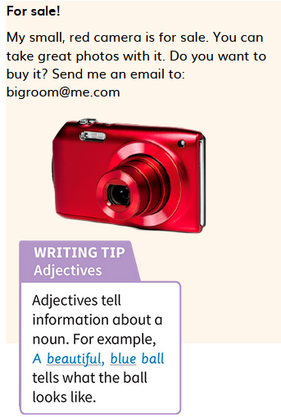

|  |
| --- |
| photos great email small red camera |

|  |  |
| --- | --- |
| Nouns | Adjectives |
|  |  |