Video Activity 1
- hats
- balloons
- presents
- cake

Video Activity 2
1 Grandpa Friendly is a farmer .
2 Jim is a doctor.
3Jenny is a pop star .
4 Mrs Friendly is a nurse .

Video Activity 3
stop. | I'm a pirate. Please
a clown costume, from the party. | I'm wearing
help other people. | Doctors
feeding the cows. | He's outside
often go to parties. | Film stars

Video Activity 4
Eva's scarecrow | Tom's scarecrow | Jim and Jenny's scarecrow
thin  tall  straight hair | fat  short  a moustache | ugly  purple nose  curly hair

Video Activity 5
- in schools
- in kitchens

Vocabulary 1
- clown
- doctor
- film star
- nurse
- dentist
- farmer
- pirate
- pop star
- cook

Vocabulary 2
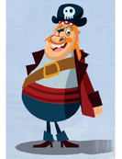 | He's tall and fat. He's got long fair hair.
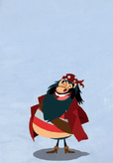 | He's short and fat. He's got straight black hair.
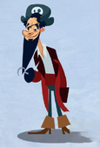 | He's tall and thin. He's got curly hair and a long beard.
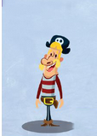 | He's short and thin. He's got a big blonde moustache.

Grammar 1
1 Today, I'm wearing a clown costume.
2 I don't usually wear clown clothes, but today is my friend's birthday party.
3 I often go to parties.
4 When I go to parties, I always give my friends presents.
5 I'm dancing with my friend now.
Grammar 2
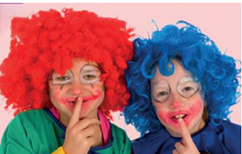  Why are they wearing costumes? | Because they're going to a party.
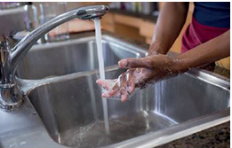  Why is he washing his hands? | Because he wants to cook dinner.
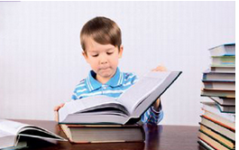  Why is he reading a big book? | Because he loves stories.
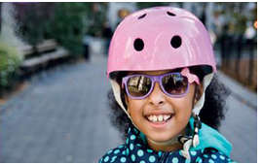  Why is she wearing a helmet? | Because she's riding a bike.

Skills
I'm wearing a clown costume | because I like dressing up.
I'm wearing a helmet | because I'm riding my bike.
I'm washing my hands | because they're dirty.
I'm wet | because it's raining.

