**Video Activity 1**

Watch the video. In the video, a girl plays football. What colour is her t-shirt?

|  |  |
| --- | --- |
| * green * purple * blue * red * orange * white |  |

**Video Activity 2**

Watch the video. Say the chant, then put the days in the correct order.

|  |  |
| --- | --- |
| Thursday Monday Wednesday Tuesday  Friday Saturday Sunday |  |

|  |  |
| --- | --- |
| 1. |  |
| 2. |  |
| 3. |  |
| 4. |  |
| 5. |  |
| 6. |  |
| 7. |  |

**Video Activity 3**

Watch the video. Look, read and choose.

|  |  |
| --- | --- |
| 1 Jim and Jenny have a fish for ... days.   * two * three   2 Jim and Jenny give the fish food ... a day.   * once * twice   3 The fish ... washes its face.   * sometimes * never   4 The fish ... talks.   * sometimes * often |  |

**Video Activity 4**

Watch the video. Sing the song, then add the missing words.

|  |  |
| --- | --- |
| 1 How often … how often … do you listen to music / films ?  2 Do you ever … do you ever … go skating in the zoo / park ?  3 Do you ever … do you ever … go shopping / skating with your dad?  4 DVD, DVD – Do you ever listen to / watch a DVD? |  |

**Video Activity 5**

Watch the video. Look, read and match.

|  |  |
| --- | --- |
| Wear goggles Wear a helmet Wear pads |  |

|  |  |
| --- | --- |
| to protect your elbows and knees. |  |
| to protect your eyes. |  |
| to protect your head. |  |

**Vocabulary 1**

Which word is missing? Read, think and choose.

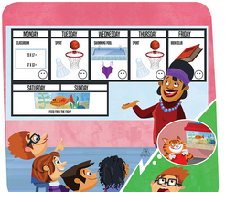

|  |
| --- |
| Wednesday Thursday Saturday Friday |

1 Monday, Tuesday, ___________ , Thursday

2 Friday, ___________ , Sunday, Monday

3 Monday, Wednesday, ___________ , Sunday

4 Sunday, Saturday, Friday, ___________

**Vocabulary 2**

Look, listen and choose.

|  |  |  |  |
| --- | --- | --- | --- |
|  |  |  |  |
|  |  |  |  |

**Grammar 1**

Read. Put the words in the correct order.

|  |
| --- |
| go shopping at the weekend. I often |

1 _________ _________ _________

|  |
| --- |
| at seven o'clock. I always my teeth clean |

2 _________ _________ _________ _________

|  |
| --- |
| on Tuesdays. often play football I |

3 _________ _________ _________ _________

|  |
| --- |
| never on Mondays. play I basketball |

4 _________ _________ _________ _________ _________

**Grammar 2**

Read and complete the library rules.

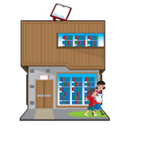

1 You must / mustn't eat in the library.

2 You must / mustn't be quiet or talk quietly in the library.

3 You must / mustn't talk on your phone in the library.

4 You  must / mustn't walk in the library. Don't run, please!

5 You  must / mustn't clean your desk when you finish reading.

**Skills**

Is the **underlined**word in each sentence a subject or a verb? Read and choose.

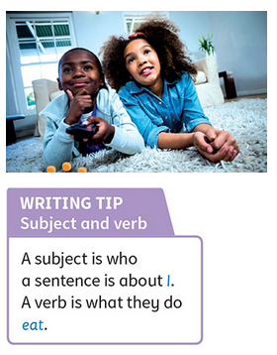

1 We often **watch**TV on Tuesdays.

subject / verb

2 **Emma** often writes emails.

subject / verb  
3 **She** always exercises on Fridays.

 subject / verb  
4 I sometimes **eat** fish for breakfast.

subject / verb